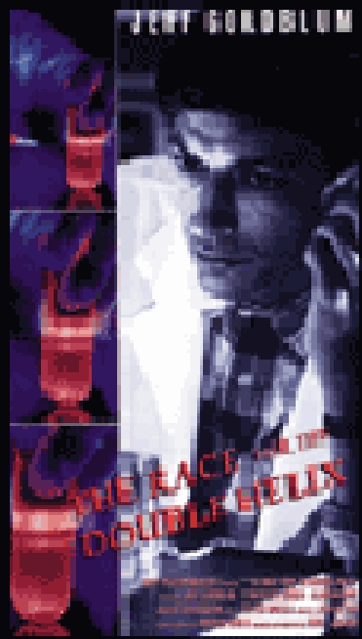Honors Biology Extra Credit Opportunity:

Spring Semester 2013

“Race““ forfor thethe Double Helix” Film Questions & Collateral

Reading: ""A Structure for Deoxyribose Nucleic Acid"" J. D. Watson and F. H. C. Crick

DUE DATE: BY Wednesday May 14th - no exceptions!

FOLLOW THESE DIRECTIONS!!

To turn in your project, email (in MS Word format attachment) to your instructor.

Include your name and period when you save the document (example: Cmueller7th RACEXC) PLEASE INCLUDE YOUR RETURN EMAIL ADDRESS ON YOUR DOCUMENT.

- To earn up to 1% extra credit to be added to the semester grade (actual % awarded based on quality) :

    - View the film Race for the Double Helix. There will be several screenings of this film after school. Listen for announcements from your instructor. They will also be posted on Bb. You won’t find this in rental stores. It is considered a “rare find.” You may find a vhs copy on amazon – but quality may not be the best (and will most likely be expensive)!

  - You are STRONGLY ENCOURAGED to view this film more than once. You will get SO much more meaning from multiple viewings compared to just seeing it once.

  - Your answers to the following questions need to be accurate and complete. Be sure to elaborate using observations from the film whenever necessary. It is important that you explain your reasoning whenever you're asked to do so.

- What were your first impressions of the main characters? Be sure to elaborate! James Watson:

Francis Crick: Rosalind Franklin: Maurice Wilkins:

- Compare the research approaches/ styles/ attitudes of Watson and Crick with those of Franklin.

- Do you think Franklin should have shared her information more freely with the others? Why or why not?

Under what circumstances do you think scientists are justified in not sharing their results with others before their research is completed?

- Do you think Watson may have had a valid point when he told Rosalind that a "fresh" look" at her work may be what was needed? Explain your reasoning.

- What important relationship between DNA nucleotides did Watson and Crick discover? What methods did they use to accomplish this?

- When Rosalind Franklin finally had the opportunity to look at the second DNA double-helix model constructed by Watson & Crick, what was her response? (write a couple of sentences summarizing what she felt and what she said)

What was Dr. Bragg’s (Watson and Crick’s supervisor) response to her?

- What were your later impressions of the main characters? Be sure to elaborate on ways they changed! James Watson:

Francis Crick: Rosalind Franklin: Maurice Wilkins:

- Why is this film titled “Race for the Double Helix”? Do you think scientific research should be a race? Why or why not?

- Do you think that women scientists are still discriminated against the way Rosalind Franklin was in the 1950s? Explain the basis for your belief.

- This film is based on a book written by James Watson, in which he very openly described his memory of the effort leading to the discovery of the structure of DNA. The book proved to be very controversial, and Watson received much criticism from other scientists for revealing the personal side of this historic research effort. Why do you imagine that other scientists reacted in this way?

Read the original paper written by Watson and Crick (April 25, 1953 (2), Nature (3), 171, 737-738). This is the document you see being prepared at the end of the film. Be sure to read the annotations (which follow at the end). Suggestion – click on printable version to read and highlight offline. This link takes you to this extraordinary document: http://www.exploratorium.edu/origins/coldspring/ideas/printit.html

- Why didn't a triple helix model work to explain DNA structure?

- What are the new, major features of the Watson-Crick model?

- What is the significance of this statement: “It has not escaped our notice that the specific pairing… suggests a

possible copying mechanism for the genetic material.” (It is suggested that you read the annotations for hints!)

- There are many who feel that Rosalind Franklin’s work was not credited to the degree it should have been. In what specific ways may this paper have generated these feelings? (see the annotations for hints!)

- Why is this paper so short? What was its purpose?

